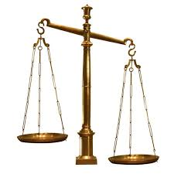
How can Europe ensure that good policy-making comes from good research, and not from bad evidence?
Brussels, 9 April 2014. The spirits sector has today called on the Commission to reconsider the evidence used in European policy-making. Efforts by some to exclude business from funding, discussing or even challenging science and research are short sighted and just plain wrong. Good evidence-based policy making depends, at least in part, on good evidence, and good research is good no matter who funds it.
spiritsEUROPE considers that there is an urgent need for a debate about the evidence used in EU public policy making and the way research is funded, conducted and presented. In many fields - including alcohol harm - discussions have become more polemic and more polarised between business on the one hand and temperance and health activists on the other. Positions become harder as research is challenged and contested. It is a situation that satisfies no one and spiritsEUROPE believes the time has come for a new dialogue and a refreshed understanding.

“We need to create the conditions for an open debate. We need to discuss how to ensure that research and evidence used by policy-makers is relevant, neutral, objective, fair, transparent and robust” said Paul Skehan, Director General of spiritsEUROPE.

“Our view is that ‘good’ research is ‘good’ no matter who funds it, provided it is carried out by real experts, and generates reputable, credible and reproducible findings that derive from sound methods, and using fair assumptions and verifiable, correct data inputs. The principles and strictures that apply to industry-funded research should equally apply to research carried out by advocate-academics who hold strong anti-alcohol views.

There is constant and justifiable focus on the need for good judgment in policy making. That focus will not diminish with the changeover to a new Commission and new Parliament. It is time for an honest debate on an important topic.”
ENDS

- spiritsEUROPE is the representative body for the spirits industry at European level comprising 32 associations and 8 multinationals. (Read more)
- Link to the full position paper (April 2014) PR-001-2014

