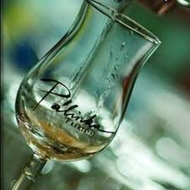

spiritsEUROPE toasts ECJ decision against Hungarian tax exemption
Brussels, 10 April 2014. spiritsEUROPE warmly welcomed today’s decision of the European Court of Justice against Hungary on the “Pálinka dossier”. In 2010, Hungary decided to exempt Pálinka from excise duty when produced by households or distilleries for personal use, up to a maximum of 50 litres a year. However, excise duties for alcohol are harmonised in Europe in order to avoid distortions of competition and under Directive 92/83/EEC Hungary is allowed to grant a 50% reduction of the normal excise rate to Pálinka - but not a full exemption. As a result, an infringement procedure was started by the Commission in 2010 which concluded today, bringing Hungary back in line with its commitments under the EU Accession Treaty.
“This ECJ judgment is important because it underlines that tax exemptions should in no case create discrimination,” said Paul Skehan, Director General of spiritsEUROPE. “Similar exemptions, which exist here and there across Europe, are not only unfair but also create opportunities for smuggling and illegal alcohol, with potential dangerous outcomes to consumers’ health. We look forward to the Commission report, due in 2015, on the impact of these exemptions across Europe,” added Skehan.
The ECJ has clearly stated that “in exempting the private production of small quantities of spirits from excise duty, Hungary has infringed EU law”. Where spirits manufactured by a distillery from fruit supplied by fruit growers are for the personal use of the latter, Hungary must apply the minimum rate of excise duty provided for by EU legislation. The Hungarian legislation, which provides a total exemption for spirits manufactured from fruit supplied by fruit growers, exceeds the maximum 50% reduction which the Directive permits. Similarly, rules exempting spirits manufactured by private individuals from excise duty are also contrary to the Directive.
ENDS
spiritsEUROPE is the representative body for the spirits industry at European level comprising 32 associations and 8 multinationals (Read more).

PR-002-2014

