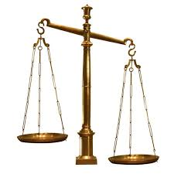

spiritsEUROPE welcomes the Scottish appeal court decision on Minimum Unit Pricing

Brussels, 30 April 2014. Today, the Scottish Appeal Court decided the MUP case should be referred to the Court of Justice of the European Union (ECJ).
"We welcome this decision. We have called for MUP to be referred to the Court of Justice of the European Union ECJ from the outset, believing that the question of its legality would always have to be decided there” said Paul Skehan, Director General of spiritsEUROPE. "Whatever about the legality of MUP, we have always contested the likely efficacy of the measure. Therefore, in advances of the ECJ hearing, we will continue to work with all willing partners to develop and support campaigns aimed at really reducing alcohol-related harm."
ENDS
spiritsEUROPE is the representative body for the spirits industry at European level comprising 32 associations and 8 multinationals (Read more).

Summary of the Court Decision published today at http://www.scotcourts.gov.uk/opinions/2014CSIH38.html

PR-003-2014

