HIGH SPIRITS: EXPORTS HIT RECORD €10 BILLION
Brussels, 9 April 2013 – European spirits’ exports reached €10.2 billion in 2012, a positive growth of 20% from the €8.5 billion in the previous year. As a result, spirits are and remain the EU’s biggest agri-food exports and generated a positive balance of trade close to €9 billion last year.

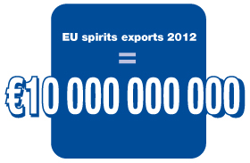 | 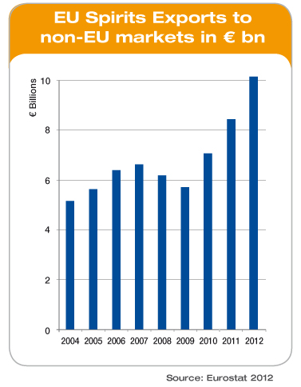

Looking closely at key exports markets, we see a solid growth in the USA (over €3 billion with a 22% increase) and Canada (with a 31% increase compared to 2011). These two markets continue to be attractive for our European products. The rest of the top ten exports markets are from emerging countries with increasing demand for premium branded European spirits:
- Growth is driven by the whiskies category (44% of spirits exports) followed by cognac (26% of total exports).
- Growth remained strong in emerging markets, driven by China (+19%) despite the economic slowdown, and South East Asia (+25%). FTAs with ASEAN countries are necessary to continue to target the huge potential in South East Asia that remains untapped.
- Growth in Eastern Europe is driven by Russia (+37%, the second largest export market overall) despite a challenging market environment.
- While India is a growing market, EU imported spirit drinks only represent a tiny fraction of the total market which should grow substantially with the conclusion of an FTA, currently being negotiated.
Paul Skehan, Director General of spiritsEUROPE said “These are great results, and show the competitiveness of the sector in some very difficult markets around the world. At a time when many domestic European markets are struggling, we underline the importance of these thriving export markets to our sector. These exports generate jobs and investment in Europe at a time when both are badly needed. And, they generate close to €9 billion net for the European economy, as imports of spirits to the EU remain steady.”

Mr Paul Skehan reiterated the need for

- Opening of new emerging markets through ambitious trade negotiations and regulatory cooperation;
- Preventing new barriers in key markets that discriminate against imported spirits;
- Allocating enough resources to the Commission, and within the Commission, to ensure implementation and enforcement of all trade agreements already negotiated.

Notes to Editor

- More export data to explore at.spirits.eu: http://spirits.eu/page.php?parent_id=11&id=56

- spiritsEUROPE is the representative body for the spirits industry at European level comprising 31 national associations and 8 multinational companies. (Read more).

- Commission contribution to the Council debate on Trade (7-8 February 2013): http://ec.europa.eu/commission_2010-2014/president/news/archives/2013/02/pdf/20130205_2_en.pdf

