Spirits sector celebrates new trading conditions with Colombia and Peru
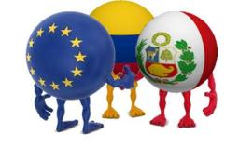
25 September 2013 – This evening, with H.E. Cristina Ronquillo, Ambassador of Peru and H.E. Rodrigo Rivera, Ambassador of Colombia, spiritsEUROPE hails the entry into force of the Free Trade Agreements with both countries. Growth and jobs will follow on both side of the Atlantic.

Trade between the EU, Colombia and Peru has grown significantly in recent years and its volume reached more than €24 billion in 2012. Colombia is the largest market in the Andean Community for European spirits, valued at €35 million in 2012, followed by Peru valued at €29 million the same year (see trends below). With imports representing only a very small part of the spirits market in each country, there is significant room for growth in both countries.
“With the FTA now entering into full implementation, we expect to gain significant benefits on both side of the Atlantic - both for our European producers and for our Colombian and Peruvian customers - and their respective economies,” said Paul Skehan, Director General of spiritsEUROPE.
“With the entry into force of the Trade Agreement, the bilateral relations with the European Union have been strengthened. This Agreement means a step forward in the universe of the relations with the European Union; will promote a better standards of living and mote resources for social inclusion.” said H.E. Mrs Cristina Ronquillo, Ambassador of Peru.
Expected benefits from the FTA
- Elimination of import tariff on trade between the partners to the FTA which will represent important savings for spirits producers.
- Fair competition between local and imported products through the elimination of tax discrimination and equal treatment of products in distribution channels.
- Legal certainty for producers on both sides, with the recognition and protection of spirit Geographical Indications (for Europe this include 21 major GIs such as Irish Whiskey, Brandy de Jerez, Grappa, Cognac, Scotch Whisky) as well as an advanced notification and consultation system for draft laws that could affect the production, distribution and marketing of spirits beverages on both side of the Atlantic.

- Efficient dispute settlement mechanism to the benefit of all to ensure implementation of obligations in the FTA and WTO agreements, avoiding legal proceedings under the WTO dispute settlement body.
ENDS

Note to editors:

- spiritsEUROPE is the representative body for the spirits industry at European level comprising 31 national associations and 8 multinational companies. With over €10bn in exports in 2012, the European spirits industry is the largest exporter in the agro-food sector to over 150 markets.

- Improved market access for the EU and Colombia and Peru. EU spirits producers will see the elimination of import tariffs on EU spirits drinks (15% for Colombia and 9% for Peru) which will represent an important saving for the spirits sector. Equally Colombia and Peru will see a reduction in tariffs on rum as well as continued duty-free entry for all other spirits products. For Colombia only, the EU spirits industry has paid €35 million in import duties over the last 10 years. As for Colombia and Peru, spirits already enter the EU duty- free, apart from rum which will see reduced tariff rates.

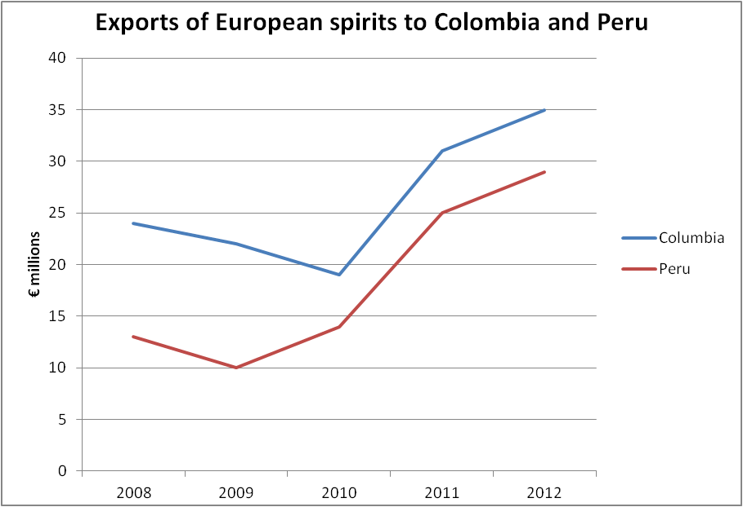

Source: Eurostat data 2012

