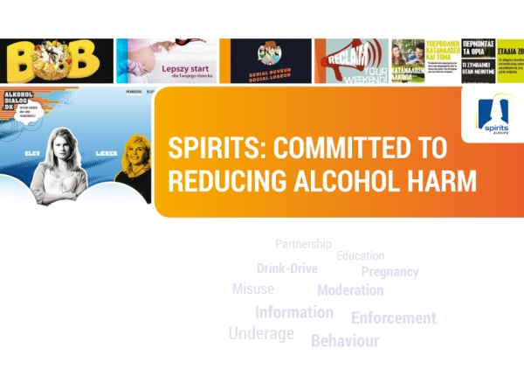

**A call for discussion and collaboration, instead of polarization and polemics…**

**Brussels, 30 October 2014. *To address alcohol-related harm, spiritsEUROPE believes that all stakeholders need to work together more closely; that the current polemic, polarized debate is counter-productive; and that the focus for policy makers and others must be to reduce harm, not consumption per se.***

spiritsEUROPE makes this case in a new publication launched today. The publication addresses the state of play of alcohol consumption in Europe, with both positive and negative trends in evidence. It presents what the spirits sector has been doing so far, as well as recommendations for a holistic approach to reducing alcohol-related harm.

“Our sector has previously stated its willingness to work with all relevant stakeholders – from the public, private and NGO communities and we reiterate that offer with renewed urgency” said Paul Skehan, Director General of spiritsEUROPE.

“Currently, the fight against alcohol harm is too fragmented, and lacking in coordination”, added Paul Skehan. “We firmly believe that only by working in partnership will it be possible to seriously reduce the problems resulting from abuse. Collectively, we need more constructive discussion about the real problems, their causes and the remedies we might all apply towards this joint objective of harm reduction” he added.

Paul Skehan concluded by insisting that “Anything and everything stakeholders do - from policy to actions - should be based on robust evidence”.

**ENDS**

**Notes to Editors:**

* **spiritsEUROPE** represents the spirits industry, comprising 32 associations and 8 multinationals.
* Our sector long commitment is reflected in 317 prevention initiatives in place since the inception of the European Alcohol and Health Forum: see[www.drinksinitiatives.eu](http://www.drinksinitiatives.eu)**.**
* spiritsEUROPE encourages responsible commercial communications, including online training**:** [www.marketresponsibly.eu](http://www.marketresponsibly.eu).
* spiritsEUROPE offers an EU portal to direct consumers to local information & guidance on what is responsible drinking: [www.responsibledrinking.eu](http://www.responsibledrinking.eu) .
* Publication available by clicking [here](http://spirits.eu/files/24/cp.as-096--spirits-and-society-brochure-sept-2014.pdf).

PR-007-2014