Calorie information to consumers
as part of responsible drinking messages
spiritsEUROPE launches a fully revamped responsibledrinking.eu website

Brussels, 17 July 2015. Beverages containing alcohol are often associated with sharing, pleasure, unwinding, and socialising. However, there are times when drinking at all, or too much can be risky for the individuals and others. spiritsEUROPE has now totally revamped its European portal providing consumer information. The responsibledrinking.eu website, and the national information websites it links to, is intended to help consumers work out how much is too much and to weigh up the pros and cons when deciding to drink.

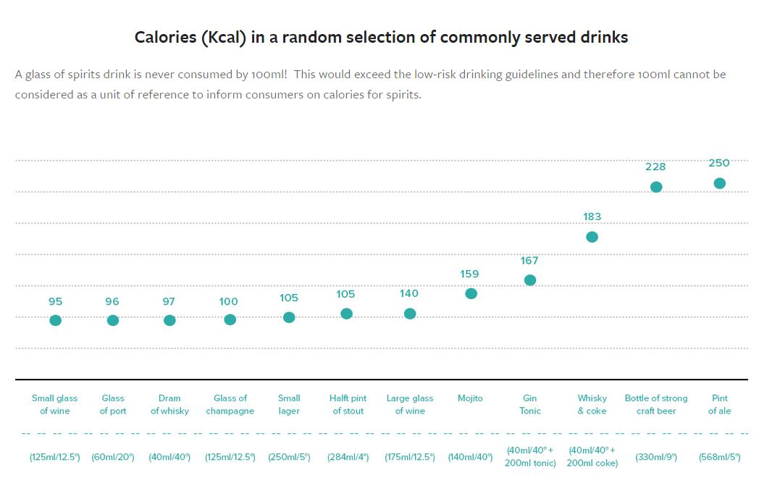
The website also provides information on how to assess calories in alcoholic beverages. “We provide calorie information by standard drinks (and not by 100ml) but also for a random selection of drinks available on the market” said Paul Skehan, Director General of spiritsEUROPE. “We aim to provide relevant, easily understandable information that addresses consumers’ needs, while waiting for the report from the Commission on energy and ingredients labeling.”
Click here to view the graph online
ENDS

