SPIRITSEUROPE APPOINTS A NEW DIRECTOR GENERAL
AND WELCOMES A NEW PRESIDENT

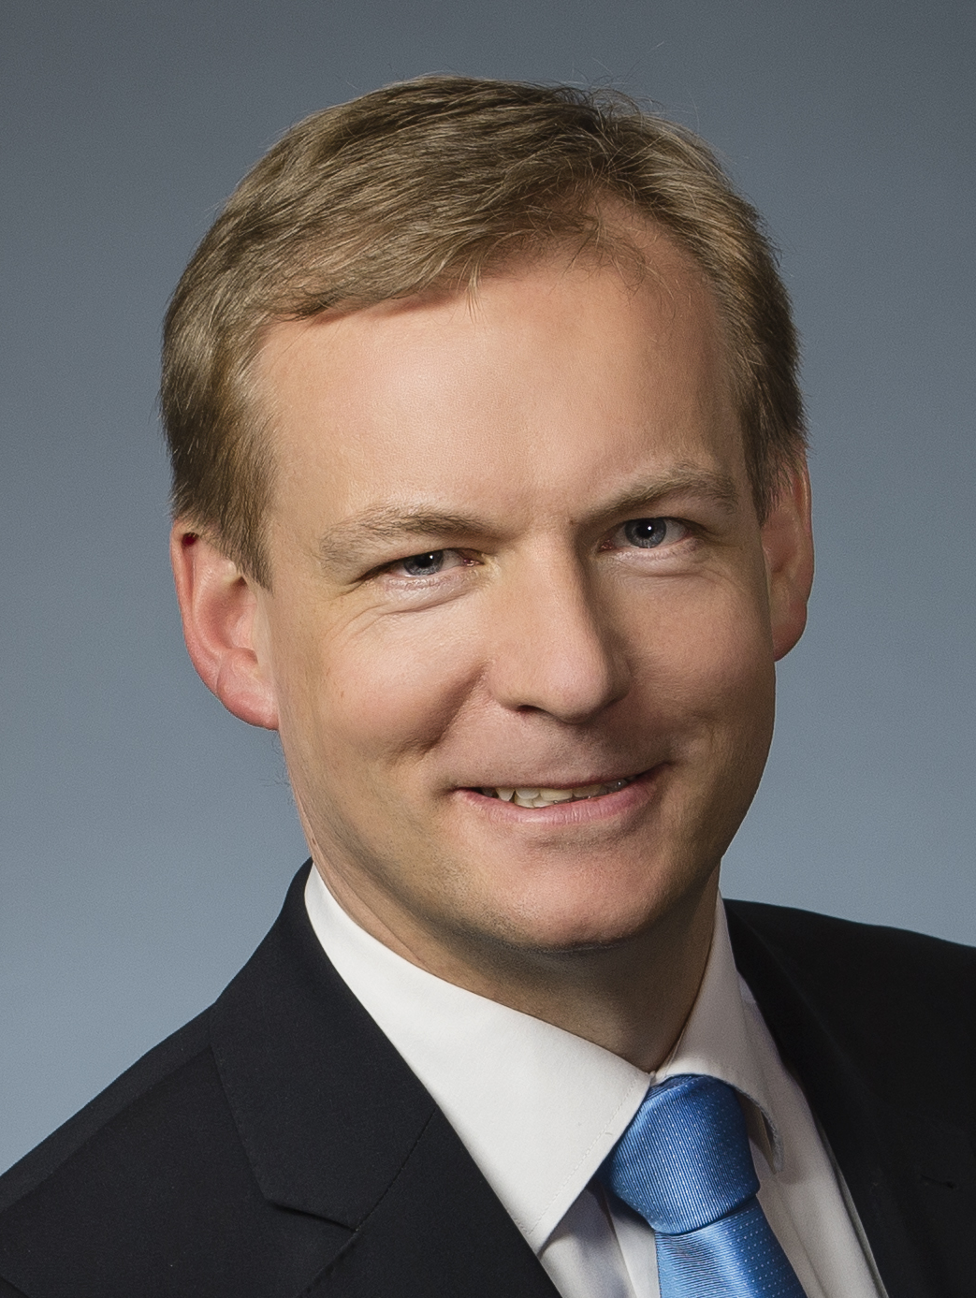 | 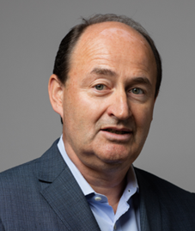
ULRICH ADAM | CHRISTIAN PORTA

Brussels, 22 November 2017 – Ulrich Adam becomes the Director General of spiritsEUROPE, effective as from 15 January 2018. Together with a new President, Christian Porta - Chairman and CEO of Pernod Ricard EMEA & LATAM - a renewed team will lead the organisation in the new year.

On 22 November 2017, Ulrich Adam was introduced officially to the members of the General Assembly of spiritsEUROPE and to those who attended the spirits SUMMIT 2017. Christian Porta will be the new President of the organisation, assuming this role for a term of two years. Christian is member of the Executive Commitee of Pernod-Ricard, responsible for EMEA and Latin America.

“It is an honour and a responsibility” said Christian Porta. Christian will play a key role in helping to promote, protect and grow the European spirits industry in the EU and in third markets. “From farm to glass, spirits are an essential part of Europe’s tradition and culture of quality, pleasure and conviviality. My main objective will be to drive home to the European institutions the legitimate interests of the spirits sector as a proud contributor to Europe’s excellence that remains committed to promoting responsible drinking and sustainable growth”.

Prior to joining spiritsEUROPE, Ulrich directed CEMA, the European Agricultural Machinery Association for the last 5 years. Before that, Ulrich worked for 8 years in the Brussels Office of Hill & Knowlton Strategies as Director and Head of the Food and Consumer Affairs Practice.
“It is a great honour for me to take the leadership of spiritsEUROPE representing an iconic sector with well-deserved global reputation for quality and innovation” said Ulrich Adam, adding “I salute the legacy of Paul Skehan and the team and I look forward to addressing the opportunities and challenges facing the sector from Brexit, alcohol-related harm, consumer information or market access across the globe”.

“It is my ambition to work with our new President, staff, membership, stakeholders and EU institutions on the commitments made by the large and small distillers and to promote policies that deliver economic growth and jobs in the European regions where our production is deeply and firmly rooted” concluded Ulrich Adam.
A German national, Ulrich holds a PhD in History from the University of Cambridge.
ENDS

NOTE TO EDITORS
For more information, please contact Carole Brigaudeau at brigaudeau@spirits.eu / +32.486.117.199
      - Christian Porta has been Chairman & Chief Executive Officer of Pernod Ricard EMEA / LATAM since July 2013. After starting his career at Arthur Andersen in Audit Services for four years, he joined Pernod Ricard in 1988 as an Internal Auditor, following which he became Head of Financial Services at the holding. In 1994 he was appointed Finance and Administration Director at Pernod, before moving to London in 1998 as Managing Director of Campbell Distillers. In 1999 he was appointed Chairman and CEO of Orlando Wyndham, based in Australia, before moving back to London at the beginning of 2004 as Chairman and CEO of Chivas Brothers Ltd. Christian, 55 years old, is a graduate from ESCP Business School (Paris).

- spiritsEUROPE proudly represents the most valuable European agri-food export and with it the interests of the spirits sector in 31 national associations as well as of the 8 leading multinational companies. Distilled spirits are as diverse as the EU itself, spanning 46 product categories and including a host of geographically-specific products that contribute to the culture of their regions (240 GIs).

- The sector generates €23bn in excise duties & VAT; 1 million jobs in production & sales; and €10bn exports outside Europe.

