EU SPIRITS & WINE PRODUCERS WELCOME BREXIT PROGRESS AND
CALL FOR EXPEDITED AGREEMENT ON TRANSITION

Brussels, 14 December 2017 – The European spirit drink and wine industries welcome the European Commission’s recommendation to declare “sufficient progress” in the first phase of the Brexit negotiations, and now encourage the EU-27 leaders to support this decision.

Christian Porta, President of spiritsEUROPE comments “Our industry welcomes the progresses acknowledged in the Joint Report and fully supports the ambition for a ‘transition period covering the whole of the EU acquis’ outlined in the European Council’s draft guidelines. We now call upon the negotiators on the UK’s side to match this level of ambition. An expedited agreement is essential in reducing uncertainty for our Members, and their suppliers, across the EU-27 and in the UK”.

Our industries hope that negotiators on both sides maintain the momentum built to date, and ensure that the Joint Report is translated into a watertight Withdrawal Agreement with the minimum of delay. In doing so, we would particularly appreciate commitment for continuous full protection of our GIs and trademarks, as well as clarity on a definition of the ‘placing of goods on the market’ that takes into account the diversity of sectoral business models.

In addition, in relation to Northern Ireland, we note the need to seek further clarity on how the Irish border will work in practice and look forward to seeing concrete mechanisms proposed in the near future to resolve the issue. William Lavelle, Head of the Irish Spirits Association stated: "We welcome the agreement to avoid a hard border on the island of Ireland. We will continue to press to ensure that the final agreement protects our integrated all-island spirits industry and our cross-border supply chains. We also want to ensure that our three spirit GIs (Irish whiskey, cream liqueur and Poitín) which operate on an all-island basis, continue to be recognised and enforced equally by both Irish and UK authorities."

Jean-Marie Barillère, President of CEEV adds “We need clarity on exactly how these political statements of intent will be translated into technical and operational realities. Looking ahead, an early agreement securing continuous full protection of the PDO/PGIs for wines and GIs for spirit drinks is central to our ability to continue to prosper as European export champions”.

Our industries continue to share an ambition for a wide-reaching gold-standard FTA between the UK and the EU. We are encouraged that momentum has been reinjected into the negotiations, and it is essential that negotiators carry this optimism forward into the next stages of the Brexit process.

- ENDS -

NOTE TO EDITORS
Detailed the joint position paper / Executive Summary here
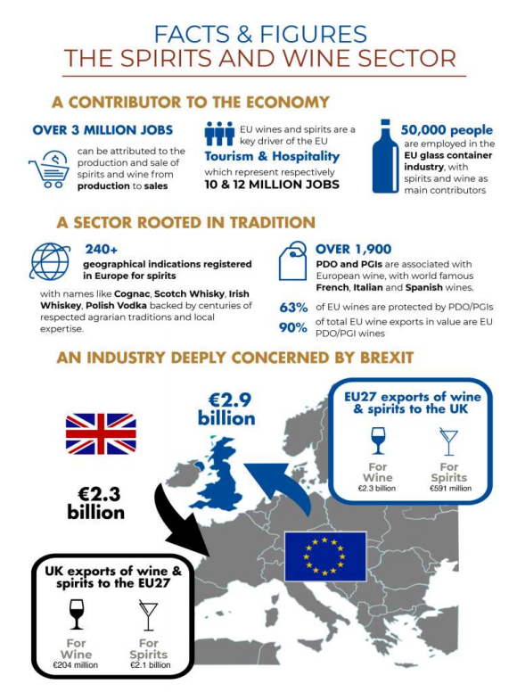

spiritsEUROPE - Carole Brigaudeau  brigaudeau@spirits.eu / +32.486.117.199  Irish Spirits Association - William Lavelle / +353 87 711 2063 | SWA - Rosemary Gallagher rgallagher@swa.org.uk / +447432605385 or Beatrice Morrice bmorrice@swa.org.uk / +447432605387
WSTA - Lucy Panton lucy@wsta.co.uk  +447776422656 | CEEV - Dr Ignacio Sanchez Recarte  ceev@ceev.eu / +32.476.88.36.75

