***SPIRITS WELCOME FURTHER EVIDENCE OF DECLINE IN UNDERAGE DRINKING IN THE EUROPEAN UNION***

***Brussels- 20 September 2016. The new ESPAD study - released today - confirms that the efforts made by all stakeholders towards eliminating underage drinking are delivering tangible results.***

Since ESPAD survey is undertaken, we have reached the lowest ever observed percentage of students who reported alcohol consumption in the last 30 days in the EU with a decline of 24% since 2003 (from 67% to 51% between 2003 and 2015). Another important indicator is the level of intoxication: 86% of European students are reporting “never being drunk” in the last 30 days (an improvement of 23% since 2003). Another positive trend to be noted is the frequency of heavy episodic drinking which decreased by 28% since it peaked in 2007 (18% in 2007 down to 13% in 2015). These positive trends can be observed for both boys and girls!

These ESPAD results reinforce the downward trend already shown in the WHO’s ‘Health Behaviour in School aged Children’ (HBSC) study released in March (2). “*We are delighted to note that two major surveys on minors point to decreasing trends in underage drinking in Europe, irrespective of whether or not countries have restrictive population measures, such as pricing policy or advertising bans, in place*” said Paul Skehan, Director General* of spiritsEUROPE.

“*Clearly, while we should celebrate the positive trend, there is no room for complacency*” said Paul, adding “*A closer look at the data shows that alcohol consumption by minors varies greatly across Europe and we need to continue assisting those most at risk*”. The fact that the incidence of underage drinking varies so much between different countries underlines the importance of targeted initiatives, which take local culture, context and issues into account. A one-size approach, targeting entire populations, is not the answer.

“*Combatting underage drinking, in partnership with local authorities and communities, is a core, long standing commitment of the spirits sector*” said Paul Skehan. spiritsEUROPE members and their partners at local level are vocal and active supporters of strict - and fully enforced - Legal Purchasing Age regulations but they also support programmes to change the social norms around underage drinking by engaging the most important determinants behind underage drinking: parents and peers.

For example, in the UK, the Community Alcohol Partnership programme contributing to the 36% drop in alcohol consumption by the 11-15 years old. In Spain, the vast industry-funded campaign of “Minors, not a single drop” is also producing results: in 2012-2013, 81.9% of 14 to 18 year olds tried alcohol over the previous 30 days compared to 68.2% in 2014-2015.

“*These results are very encouraging and we will continue to support investment in initiatives giving tools to parents and teachers, and support life skills programmes*” concluded Paul Skehan. Scientific evidence shows that such interventions positively influence risky behaviour patterns among youth, not just related to alcohol.

ENDS

**Note to editors**

*in his capacity as permanent representative of Skehan sprl

* **spiritsEUROPE** is the representative body for the spirits industry at European level comprising 31 associations and 8 multinationals: [www.spirits.eu](http://www.spirits.eu)**.**
* Overview and **examples of initiatives** taken at national level to address alcohol related harm: click [here](http://spirits.eu/files/24/cp.as-057-2016-looking-back-to-better-look-forward-brochure.pdf)

**END NOTE - ESPAD**

ESPAD is an important source of information on drug and alcohol use among European school students and is invaluable for recording trends over time. ESPAD is a collaborative effort of independent research teams in more than forty countries (EU and non-EU countries – **UK is missing in 2015**). The results of the periodic survey are published in collaboration with collaboration with the EU drugs agency (EMCDDA) in Lisbon. The use of standardised methods and instruments among nationally representative samples of school students aged 15–16 year olds provides a high-quality and comparable data set.

When we compare these results to previous years, some trends become obvious

* Overall, underage alcohol consumption in the last 30 days declined by 24% from 67% to 51 % between 2003 and 2015. It is now below the 1999 level (64%). ([table 55](http://www.espad.org/report/table-55-use-any-alcoholic-beverage-during-last-30-days-gender-1995-2015-percentages))

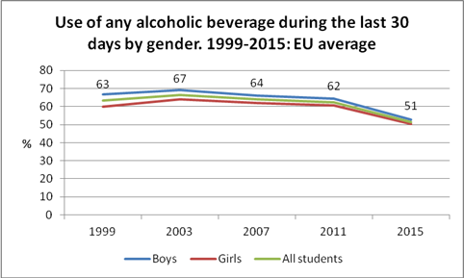

* Problem drinking is not a typical characteristic of Europeans under the legal purchase age. Today, 86% of students reported ‘never being drunk’ in the previous 30 days. A positive improvement of 23 % compared 2003 (from 70% in 2003 to 86% in 2015) ([table 23 b](http://www.espad.org/report/table-26b-having-experienced-problems-during-last-12-months-occurred-because-someone-elses))
* Significant declines in the reported drunkenness 3 times or more in the last 30 days since 2007: Another positive trend to be noted in the frequency heavy episodic drinking which decreased by 28% since the pick point 2007 (18% in 2007 down to 13% in 2015).([table 55](http://www.espad.org/report/table-55-use-any-alcoholic-beverage-during-last-30-days-gender-1995-2015-percentages))

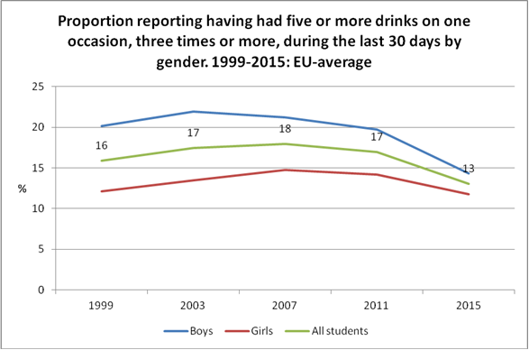

**End note 2 – HBSC**

HBSC study is conducted every 4 years, and the latest study was published on [15 March 2016](http://www.euro.who.int/en/media-centre/events/events/2016/03/health-behaviour-in-school-aged-children-hbsc-study-launch-of-an-international-report). It covers more than the EU (most of WHO EURO region country as well as US and Canada), and is based on the compilation of data from a survey done in 2014. The data focus on social context (relations with family, peers and school), health outcomes (subjective health, injuries, obesity and mental health), health behaviours (patterns of eating, teeth brushing and physical activity) and risk behaviours (use of tobacco, alcohol and cannabis, sexual behaviour, fighting and bullying).

The HBSC study, published in March, shows a positive trend regarding underage drinking in Europe.

* Delay in the age of onset: between 2006 and 2014, there is a reduction of 32% of those reporting a first alcohol use at the age of 13 or younger. Boys still drink more than girls but the gap is narrowing. Ireland, the Netherlands, Belgium and the Czech Republic have recorded the high percentage decline (55% in Ireland to 64% in the Czech Republic).
* The percentage of 11, 13 and 15 year-olds who consume alcohol at least once a week has halved from 2014. Put another way, that means more than 85% of underage European 15 year olds do not drink at all, compared to only 70% in 2002. The countries with the biggest decline are Sweden, the UK, the Netherlands, Ireland and Spain.
* Fewer minors are reporting drunkenness but there are still great disparities between countries and gender, reinforcing the need for a local and targeted approach.
* For all EU Member States reported, first drunkenness at the age of 13 or younger declined between 2006 and 2014. The sharpest declines can be observed in Austria, Ireland, the Netherlands, and Belgium (between 66% and 67%).
* By the time they are 15 years old, the reported drunkenness at least twice is higher but still on the decrease compared to previous surveys. Taking the UK again as an example, the percentage was respectively 55.1% for boys and 55.7% for girls in 2002 and is now down to 28.3% for boys and 32.6% for girls.