Embargoed till 6 am on 15 November 2016
INFORMATION CAMPAIGN ON CALORIES OF ALCOHOLIC DRINKS
IN BRUSSELS’ METRO STATIONS

Brussels- 15 November 2016. European spirits sector launches a consumer information campaign on calories in alcoholic beverages per glass, also warning on the risk of confusion if the information is provided per 100ml instead.

spiritsEUROPE provides calorie information on www.responsibledrinking.eu website (promoted at national level through brand advertising) and has decided to run an advertising campaign in a number of metro stations in Brussels to raise awareness and attract visits to the website.

“We want consumers to receive meaningful information to enable them to take informed decisions” said Paul Skehan, Director General of spiritsEUROPE. At the moment, alcoholic beverages are exempt from some parts of the Food Information to Consumer Regulation 1169/2011 but the Commission is expected to publish a report shortly on ingredients and energy for alcoholic drinks.

“We fully agree we should provide information on calories and alcohol content; we want this information to be given per serving, on the basis of 10g of alcohol per glass, and not per 100ml” said Paul Skehan. “We strongly believe that using 100 ml as a reference point for alcoholic beverage makes no sense, is deceptive and will confuse rather than inform consumers”. Indeed, while 100ml is usually a fraction of the amount of beer a person might consume in one serving, it can equal to three servings of spirits: the maximum daily recommendation for men and beyond what is recommended for women. “In addition, information to consumers about calorie content should not confuse the messages about responsible drinking which we are have been promoting for decades””.

“We are committed to promoting the use of smart, innovative ways to inform consumers, rather such as websites, QR codes, apps, logos, etc. and to accompany these online initiatives by combined wider communication efforts, through various supports and solutions, to ensure that consumers are far more aware than at present that the information is available” concluded Paul Skehan.

ENDS

Note to editors

- spiritsEUROPE is the representative body for the spirits industry at European level comprising 31 associations and 8 multinationals: www.spirits.eu.

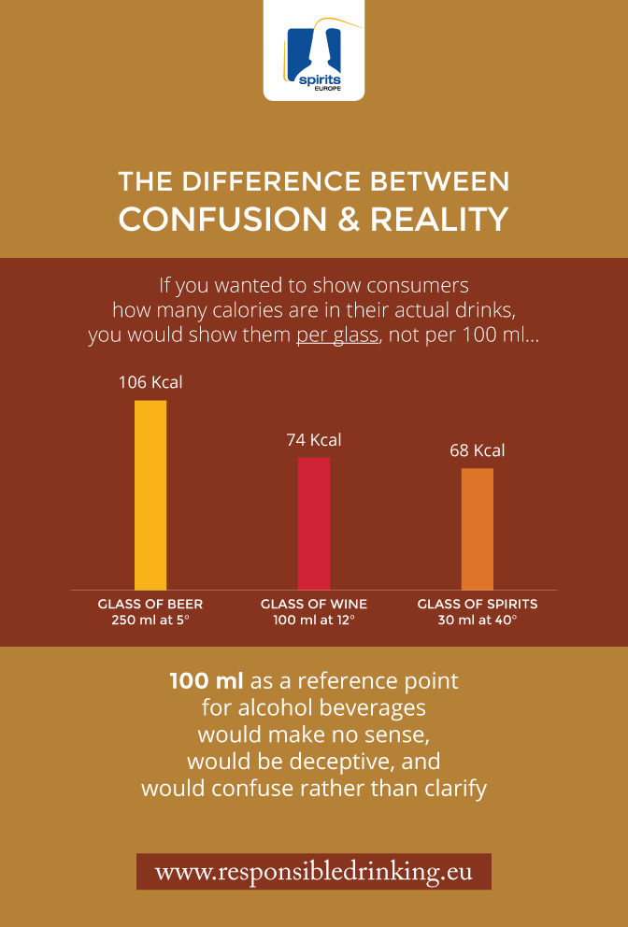

END NOTE – FACTS ABOUT CALORIES AND ALCOHOL
1. Alcohol accounts for a small fraction of calorie intake: We estimate that consumption of alcohol accounts for a relatively small part of the calories consumed in Europe. Around 5.6% of the total daily intake (3405 Kcal) comes from alcoholic beverages (1).

2. Calorie intake from spirits has been decreasing for years: In looking at the same data as used above, the number of calories from spirits in the diet fell by 10.5% between 1994 and 2013. It has remained stable for wine and dropped by 7% for beer (2).

3. Beer contributes more than 50% of all calories derived from alcoholic beverages: Of the small percentage of calories attributable to alcohol, beer accounts for just over half. Wine accounts for 30% and spirits just 20% (3).

4. Consumer information is useful only when it is understandable: Using a 100ml measure misrepresents the calorie content for spirits, wine and beer. In particular, it artificially inflates the level for spirits and presents a deceptively low level for beer. It also compromises the responsible drinking messages that we have built over the years to inform consumers on low-risk drinking guidelines. The notion that consumer information on calories might be based on the equivalent of 3 measures of a 40% proof spirit goes against the principles of all our awareness-raising campaigns targeting alcohol harm over the past 10 years.

While there are no harmonised serving sizes across the EU, it is not unreasonable to compare calorie levels in, e.g. 30ml of spirits, 100ml of wine and 250ml of beer, all of which contain about the same amount (10g) of alcohol. A comparison on this basis would mean consumers receive meaningful information that would allow them to understand what they are drinking. If we look at the average number of calories per standard servings, i.e. sizes that normal consumers understand - we see a very different picture:

 | Beer (250ml, 5%) | Wine (100ml, 12%) | Spirits (30ml, 40%)
Calories per serve / 10g unit | 106 | 74 | 68
Calories per 100ml | 43 | 70 | 222

Source of data to measure calorie intake from beer, wine and spirits
Alcohol calorie data are obtained by crossing WHO per capita consumption of beer, wine and spirits (latest available in a maximum of EU countries = 2013 > EU-27, missing Estonia) with the total calorie intake data taken from the "Dietary Energy Supply (DES)" dataset of Food and Agriculture Organization of the UN (FAOSTAT).

(1) – Calculation for 2013
- Per capita consumption in 2013 (WHO) of beer (4.2 litres of pure alcohol), wine (3.4 litres of pure alcohol) and spirits (2.4 litres of pure alcohol) to be converted into litre of final product.
- Calories per 1 litre of wine (at an average of 12° abv) =740 Kcal; 1 litre of beer (at 5° abv) = 424 Kcal; and 1 litre of spirits (at 40° abv) = 2267 Kcal.
- Beer: (4.2 l of pure ethanol x 0.05) x 424 Kcal / 365 days = 97.6 Kcal/day
- Wine: (3.4l of pure ethanol x0.12) x740 Kcal / 365 days= 57.4Kcal/day
- Spirits: (2.4l of pure ethanol x 0.40) x 2267 Kcal / 365 days = 37.5 Kcal/day
- Therefore, approximate total calories from alcohol in 2013= 192.3 Kcal. which represents 5.6% of the total daily calorie intake (3405Kcl).

(2) – Calculation for 1994
- Per capita consumption in 1994 (WHO) of beer (4.5l of pure alcohol), wine (3.4l of pure alcohol) and spirits (2.7l of pure alcohol) to be converted into litre of final product.
- Total daily calorie intake in 1994 was: 3250Kcal of which 6.9% came from alcohol consumption (i.e. 3.3% from beer; 2 % from wine and 1.6% from spirits consumption).
- Calories per 1 litre of wine (at an average of 12° abv) =740 Kcal; 1 litre of beer (at 5° abv) = 424 Kcal; and 1 litre of spirits (at 40° abv) = 2267 Kcal.
- Beer: (4.5l of pure ethanol x 0.05) x 424 Kcal / 365 days = 104.5 Kcal/day (down to 97.6 Kcal in 2013 = a 7% decrease)
- Wine: (3.4l of pure ethanol x 0.12) x 740 Kcal / 365 days= 57.4Kcal/day (the same as in 2013)
- Spirits: (2.7l of pure ethanol x 0.40) x 2267 Kcal / 365 days = 41.9 Kcal/day (down to 37.5 Kcal in 2013 = a 10.5% decrease).

(3) More than 50% of (alcohol beverage) calories derives from beer
In 2013, 97.6 Kcal come from beer consumption out of total calorie intake from alcoholic beverages of 192.3 Kcal, i.e. more than 50%. 57.4 Kcal comes from wine, i.e. 30%, and 37.5 Kcal from spirits, i.e. 20% of the total 192.3 Kcal.

