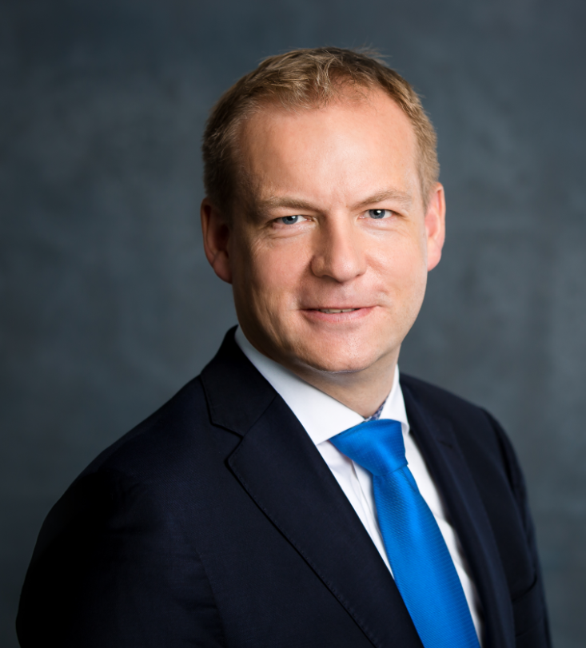

Ulrich Adam, Director General - spiritsEUROPE

Ulrich Adam has been Director General of spiritsEUROPE since January 2018

Prior to joining spiritsEUROPE, he was Secretary General of the European Agricultural Machinery Industry Association (CEMA) from 2013 until 2018.

Previously, he worked for 9 years in the Brussels office of the international consultancy firm Hill+Knowlton Strategies, advising a wide range of companies and associations on EU legislation, with a particular focus on EU policies in the areas of food, health and agriculture.

A German national, Ulrich holds a PhD and MPhil degree in History and Social and Political Sciences from Cambridge University (UK).

