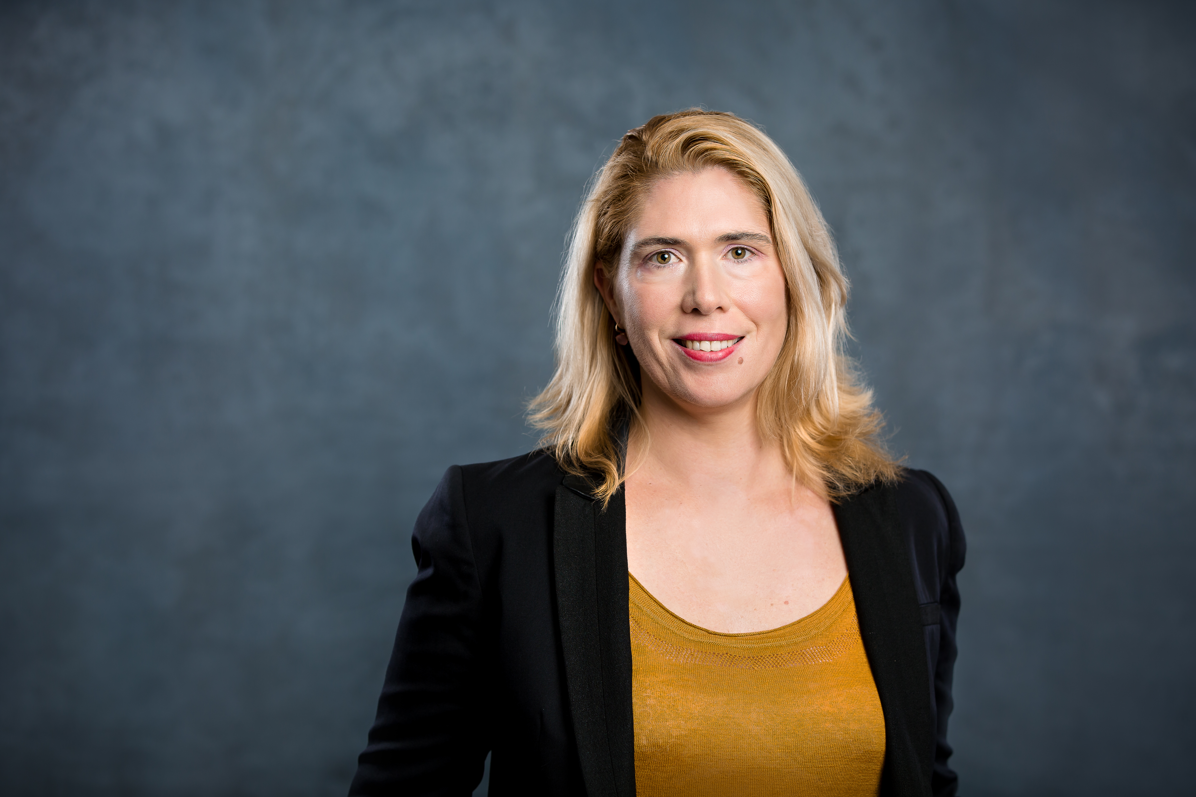

Marie is Deputy Director General of spiritsEUROPE, the European association representing spirits producers. She has over 15 years’ experience in EU public affairs.
In spiritsEUROPE, Marie leads the industry’s efforts to improve the global competitiveness of EU spirits producers by advocating the elimination of trade barriers as well as pushing for agreements and treaties to open up new export markets to create jobs and growth. In this capacity, she is also responsible for day-to-day support of members on tax and regulatory challenges and coordinates internal activities on Brexit.
Prior to joining spiritsEUROPE, Marie worked as an adviser in the EU office of the French business federation, MEDEF.
Marie is a French national. She holds a Master’s degree in “European studies” from the Louvain-la-Neuve university (UCL) and a Master’s degree in “Public Administration” from Sciences Po (Institut d’Etudes Politiques, Rennes). In addition to her native French, Marie speaks fluent English.

